**START:** To launch the program, compile the program in the MARS MIPS environment and hit the run button.

Once the program is running, you will be given a prompt on which color you would like to choose. To choose, input “B” or “W”, to choose black or white respectively, then press enter. Remember, black goes first in reversi.

**PLAY:** Once you have chosen a color, you will be prompted to make a move, as seen below.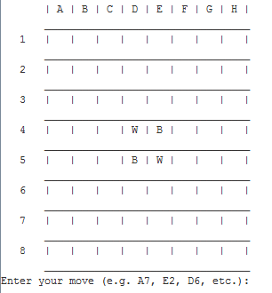

To make a move, input the letter associated with the column you want to put your piece in, then put the number associated with the row in a format such as D6. Be sure to capitalize the letter of the selected column, or else your input will be invalid, and you will have to type in your move again.

**GOAL:** Moves can only be made that would result a row, a column, or a diagonal line with your color on the ends, and the enemy color on the inside. This will flip all enemy tiles into your own. The goal of the game is the end with the most pieces.

**ENDING:** When a player can no longer make any moves, the active player loses the game and the other player wins. The game ends when no players can make any more moves, and the person with the most spaces wins.